Excel 1

Overview
What is Excel? Excel is designed to be an easy to use yet versatile spread sheet system, and it achieves just that. No matter how simple or complex your plans may be Excel, properly used, will cover your spreadsheet needs.

Class Goals
- To be able to create, edit and format a basic spreadsheet
- Become comfortable working in the Excel environment
- Learn how to add the components that make our spreadsheets more informative and visually pleasing.

Getting Started
Step 1: Create a new Workbook
A workbook is a collection of spreadsheets (1 or more) organized together. When we want to start a new spreadsheet that doesn't belong in any of our existing workbooks we need to create a new workbook. This is done by:
-Open the "File" menu
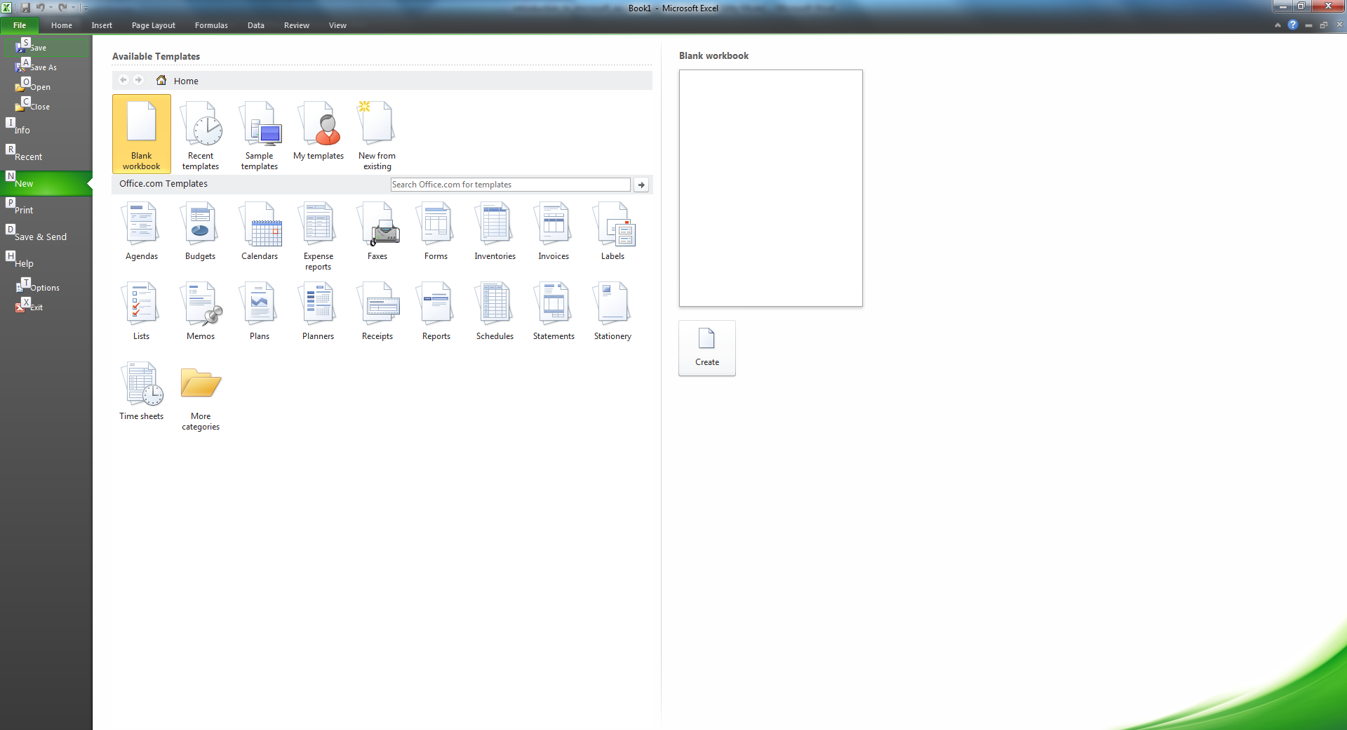
-Select "New"
-Double-click "Workbook" which
can be found in the General tag.
Step 2: Design
The next thing we need to do is
organize our thoughts and decide
how we intend to design the spreadsheet. Proper planning is important in Excel because there are so many radically different options and choices available to you.
Step 3: Entering Information
You have on your screen a grid that looks like this:
To enter information into a specific location on the
grid simply left click on the box you want to edit
(box A1 is selected in the image) then begin typing
the desired information.

Basic Skills:
- Editing information: This is done in a similar manner as in Microsoft Word. The highlighting technique is the same, the formatting toolbar is familiar, and the "Edit" menu is almost indistinguishable. The only technique that bears mentioning is the Format menu. In this menu you won't find "Paragraph" or any of the other topics you would see in word, and this makes sense since there aren't any paragraphs in Excel. What we have in the place of paragraphs are cells, rows, columns, and sheets; therefore those are the categories offered by the format menu. We'll take some time in class to look at these individually.
- Changing cell size: Dependent on what information we want to put in an individual cell we can be called on to change its size to best fit our needs. This is done very simply and is very much like changing the size of a window. However, we cannot change the size of just one cell. The spreadsheets have to maintain their geometric regularity so we are only allowed to change the width of entire columns, or the height of entire rows (or both). As an example we'll change the width of field 'A' in our spreadsheet:
  - Step 1: Place the mouse on the faded bar that separates field 'A' and field 'B'
  - Step 2: Drag the faded bar to the left or right, depending on whether you want to make it smaller or larger, respectively.
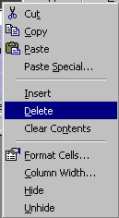
  - Done!
- Inserting and Deleting Rows and Columns: To delete a row or column you must right-click on the header (gray rectangle with either a capital letter or a number in it) for the row/column you wish to delete. This will open a menu, from this menu choose "Delete". The row/column has been deleted. Similarly, inserting a row/column can be performed by right clicking on the header of the row/column you want to insert a new row/column in
front of.
EXERCISE
- Create new worksheets: We will create a new worksheet (NOTE: not a new workbook) using the "Insert" menu. Open this menu and choose "Worksheet" and you're done. Notice that you can also insert rows and columns from this menu.

More Advanced Skills
- Inserting images: This is performed using exactly the same techniques as in Microsoft Word 2007 so I won't spend too much time on this (other than running through an example). To insert the image we again use the "Insert" menu. This time, however, we choose "Picture→From File". Then we browse through our directories using standard Windows techniques and select the file we want to insert.
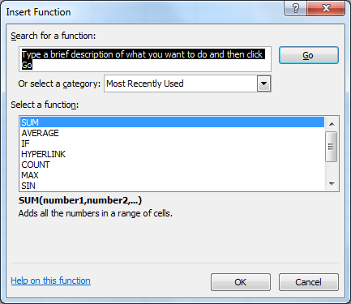
- Inserting functions: What do we mean by "functions"? Functions are operations performed on rows or columns, these operations take any number of inputs and have one unique output. We use functions like "Sum" to add all the values in a column or "Product" to calculate the result of two rows multiplied together. To determine where the output will be displayed we select the cell of our choice then open the "Insert" menu. Select "Functions…" from the menu, this will open a new window, displayed here: There are two different choices to be made here, one
(Function Category)
decides what category of
functions will be available to
us and the second choice (Function name) specifies exactly what function we want. When your satisfied with your choices left-click "OK" and you will move to the next windows, which are function specific (we'll discuss in class).
EXERCISE
- Set Print Area: This is very much like choosing the print option "print selection", however it's easier to use and more permanent. To set the print area first highlight all the cells you wish to have print. Next, open the "File" menu and choose "Print Area→Set Print Area". When your done with the selected area or if you want to make some changes to it open the "File" menu again and this time select "Print Area→Clear Print Area".

- Sort Data: Information in Excel documents can be sorted in a number of different ways. When you have a column you wish to sort simply highlight all the cells you are interested in sorting then open the "data" menu and select "Sort…". This will open the following window: Use of this window will be covered in class. 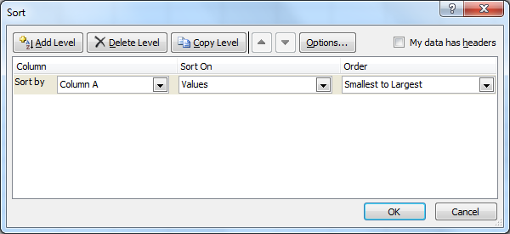
- Filters: Another process we can perform on data is filtering. If we wish to only see information matching specific criteria we can use filters to remove, temporarily, all of the records we don’t wish to see. We use filters by performing the following steps:
  - Highlight the column (or columns) you wish to filter.
  - Open the menu “Data”
  - Choose “Filter→AutoFilter
  - Now you will notice that the cell you selected has a pull-down menu attached to it, from which you can select any instance of data from the chart below. We’ll run through some examples of how to use this feature in class.
  - If you wish to filter on multiple fields first use the pull-down menu for the primary category filtered, then use the pull-down menu for the secondary. Again, we’ll discuss this issue in class.

Exercise
For those interested in practicing the skills they’ve learned today I suggest doing the following: Create a spreadsheet to balance your checkbook using the parameters in detail in class.

Formulas and Functions

Formulas
Here are some basic properties of formulas:
-All formulas begin with an equal sign(=).
-Formulas can use cell references and/or real numbers in their calculations.
-The mathematical operators Excel recognizes are: +(addition), -(subtraction), *(multiplication), /(division), ^(exponentiation), and %(percentage).
-You can add parenthesis to override the order of operations
-After a formula is entered, you’ll see the formula in both the Formula bar and the cell where you entered it, and you can edit the formula in either location.
-If you want to see all the formulas on your worksheet at once, instead of their results, you can switch the worksheet display. Press Ctrl + ` to toggle between formulas and results, or click Tools, Options, and on the View tab, check the Formulas check box to show formulas, clear the box to show results.

AutoSum
The purpose of AutoSum is to quickly write the most commonly used Excel formula, adding a column or numbers. Generally AutoSum will be able to guess which fields you want added together but it can and does make mistakes so you do have the option of editing the formulas created the same way you would edit a formula you created. To use AutoSum, follow these steps:
- Click in the cell where you want to display the formula result.
- Click the AutoSum button on the Standard toolbar. Excel guesses which cells you want to include, and surrounds them with an animated border.
- If the formula doesn’t have an obvious row or column to sum, or if it guesses wrong, drag to select the cells you want to sum. The animated border surrounds all the cells you drag.
- When the range is correct, press Enter(or click the Enter button, the green check mark left of the Formula bar) to complete the formula.

Excel Hotkeys
Bold Ctrl + b|2 Italics Ctrl + I|3
Underline Ctrl + u|4 Spell Check F7
Create Chart F11 Cut Ctrl + x
Copy Ctrl + c Paste Ctrl + v
Print Ctrl + p Save Ctrl + s
New Workbook Ctrl + n Open Workbook Ctrl + o
Next Column Tab Previous Column Shift + tab
Next Row Enter Previous Row Shift + Enter
Format Cells Ctrl + 1 Find Ctrl + f
Help F1 Select all Ctrl + a
Delete Ctrl + d Find and Replace Ctrl + h
Insert Hyperlink Ctrl + k Close Workbook Ctrl + w
Strikethrough Ctrl + 5 Show All Symbols Ctrl + 8
Hide Row Ctrl + 9 Hide Column Ctrl + 0
Hide Standard toolbar Ctrl + 7
Delete Row/Column Ctrl + -
Class Evaluation Sheet

Class attended:
Date:
General suggestions or complaints:

Is there anything I covered too much?

Is there anything I didn’t cover enough?

Was there enough time for questions?

Did I answer your questions to your satisfaction?

Are there any classes you’d like to see us offer?

Did I move too quickly? Too slowly?

