Excel 2

Links

Paste Special
Cutting and Pasting is certainly an acceptable way to move information around or reproduce the format of a document. However, if you want your workbook to carry current, frequently changing data from another source, it’s not enough. In this situation cutting and pasting would only give you the current results in a column, if we use the “Paste Special” technique we can create a link between the two documents that will pass the information along every time it changes. To perform this use the following steps:
- Highlight the field you want to link from
- Make a copy of the field(use ctrl + c or whatever technique you like)
- Highlight the field where you want the link to appear
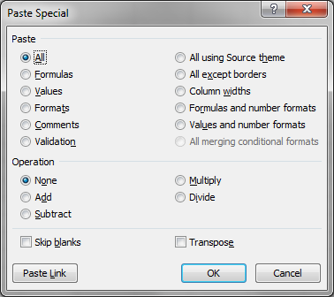
- Left-click on the pull down arrow below “Paste” on the Home ribbon
- Choose “Paste Special”
- This window should appear:
- Set the values to whatever is appropriate (we’ll discuss this in class), and click the “Paste Link” button. Finished!

Updating Links to a Workbook
Whenever you open a workbook that has one or more links from other workbooks you’ll be asked whether you want to update your information. What does this mean? Well since it’s possible that the information in the source workbook has changed since the last time you opened this file(the destination workbook) it needs to go look in the source to see if anything is different. Do you need to do this? No, if you’re not looking at the information now(e.g. you’re editing a different part of the workbook) or if for any other reason you’re not concerned with having the most current information then you can simply say no. It’s not a permanent decision, next time you open the workbook you’ll get the same choice again. If you do decide to update the link between the workbooks follow these steps:
- Click “Yes”
- In the document containing the linked material(the target) choose “Edit”, “Links” to display the Links dialog box(shown below).
- In this box click the link you want to update in the ”Source file” list.
- Click the “Update Now” button
- Click OK

Copying Excel Data to other Applications
This is much easier than you would think. If you want to copy an element of excel(e.g. a spreadsheet, chart, tally sheet, or anything you’ve created) to Word or PowerPoint simply perform the same cut & paste that you would if copying something from Excel to Excel. The Clipboard is shared between Office applications so you’ll be able to paste without any trouble.
Combining the two things we’ve discussed so far you might naturally ask the question, “Can I use Paste Special in other Office applications?” The answer is yes. It’s just as simple and straightforward in word as it is in Excel. In fact you can follow the same steps as performed above(see page one).

Embedding Excel Data In Other Office Applications
What’s the difference between embedding and linking? When you link to something in Excel you transfer information over to the target, when you embed an Excel document you not only transfer the information, but Excel itself. So an embedded Excel file will have all the options for changing and editing that you’d have if you were actually running Excel. Confused? Let’s run through an example to make this a bit clearer….(in class)
“Should I Embed or Link?” This is the first question you need to answer. If the source document that you’re linking to might become unavailable then it’s best to Embed. If you haven’t created the worksheet yet and you know that you’ll need Excel’s tools to put it together properly then you probably want to Embed. Otherwise it makes more sense to link.

Performing the Embed
- In the Word document or Power Point slide choose “Insert→Object”
- Choose existing object from a file
- Enter(type in) or browse for the path and file name
- Click OK

And that’s all it takes to embed an Excel file.

Formulas and Functions

Formulas
Here are some basic properties of formulas:
-All formulas begin with an equal sign(=).
-Formulas can use cell references and/or real numbers in their calculations.
-The mathematical operators Excel recognizes are: +(addition), -(subtraction), *(multiplication), /(division), ^(exponentiation), and %(percentage).
-You can add parenthesis to override the order of operations
-After a formula is entered, you’ll see the formula in both the Formula bar and the cell where you entered it, and you can edit the formula in either location.
-If you want to see all the formulas on your worksheet at once, instead of their results, you can switch the worksheet display. Press Ctrl + ` to toggle between formulas and results, or click Tools, Options, and on the View tab, check the Formulas check box to show formulas, clear the box to show results.

AutoSum
The purpose of AutoSum is to quickly write the most commonly used Excel formula, adding a column or numbers. Generally AutoSum will be able to guess which fields you want added together but it can and does make mistakes so you do have the option of editing the formulas created the same way you would edit a formula you created. To use AutoSum, follow these steps:
- Click in the cell where you want to display the formula result.
- Click the AutoSum button on the Standard toolbar. Excel guesses which cells you want to include, and surrounds them with an animated border.
- If the formula doesn’t have an obvious row or column to sum, or if it guesses wrong, drag to select the cells you want to sum. The animated border surrounds all the cells you drag.
- When the range is correct, press Enter(or click the Enter button, the green check mark left of the Formula bar) to complete the formula.

Editing formulas
Once you’ve created a formula you are free to change it however you wish. This can be done by just deleting the errant text and typing in what you want or it can be done through a number of different mouse techniques that provide us with helpful shortcuts and visual aids. It’s difficult to express how these work so we’ll go through numerous examples in class.

Using AutoCalculate
If your looking to find out statistical information about the excel worksheet in front of you but you don’t wish to have that information inserted into the actual worksheet AutoCalculate might be the right choice. When you highlight a group of cells Excel automatically finds certain information about them. As you can see in the image below:
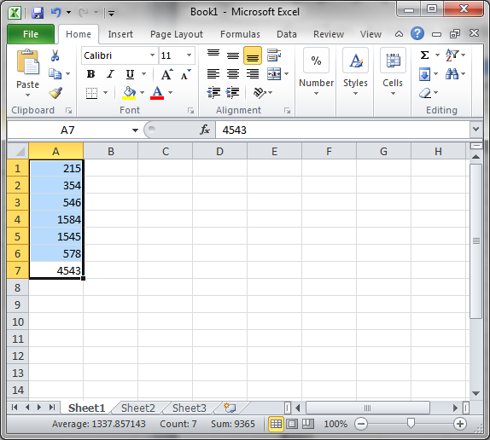
By right clicking on the status bar you can decide exactly what information you want to be automatically displayed. Average, Count, and Sum are available in the example above.

Error Values
Sometimes something prevents a formula from properly calculating. In these situations Excel will display a value to let you know what the situation is. Below is a listing of those values:
This Error | What it Means | Solution
##### | The column isn’t wide enough to display the value | Widen the Column
#VALUE! | Wrong type of argument or operand(for  Example, calculating a cell with the value #N/A | Check operands and arguments; be sure references are valid
#DIV/0! | Formula is attempting to divide by zero | Check the cell values
#NAME? | Formula is referencing an invalid or nonexistent name | Check names and spelling
#N/A | Most commonly means no value is available or wrong arguments used | In a lookup formula check table is sorted correctly
#REF! | Excel can’t locate the referenced cells. | Click Undo immediately to restore references then change formula references
#NUM! | Incorrect use of a number(such as SQRT(-1)) or formula result is a number too large or small to be displayed | Be sure that the arguments are correct, and that the result is between –1*10³⁰⁷ and 1*10³⁰⁷
#NULL | Reference to intersection of two areas that do not intersect. | Check typing/reference errors
Circular | A formula refers to itself, either directly or indirectly. | Click OK then remove self-reference or rework formula so it’s not required.

Referencing Values in Other Worksheets and Workbooks
If, when writing your formulas, you decide you want to work with a value, or values, from another worksheet; it’s not a problem at all.
To reference data from another worksheet in your formula just follow these steps:
- Begin building the formula.
- When you are ready to insert the reference from another worksheet, click the tab for that worksheet.
- Locate the cell that you want to reference, and click it. If you’re referencing a range, drag across the range to select it. The sheet name and cell reference appear in the Formula bar.
- Continue building your formula by typing the remaining operators. If your formula requires cells from other worksheets(or from the original worksheet), repeat steps 2 and 3 to add them.
- When the formula is complete, press Enter.

If you want to enter the reference in by simply typing it follow this format:
SheetName!CellReference
If the sheet name includes spaces enclose it in single quotes.

Referencing Other Workbooks
If you need to reference data that is not only from another worksheet, but an entirely different file(a.k.a. Workbook), you need to make some slight changes to the reference format. To reference a cell from another workbook you would identify it in your formula like this:
[WorkbookName]WorksheetName!CellReference

Creating Charts

Getting Started
Charts are used as a visual illustration of the information listed in a spreadsheet. While they shouldn’t be used excessively there are times when an image can be very clarifying and convincing. There are several different ways to create charts in Excel, we’ll go over one of these techniques in class. The method for creating a chart we’ll be using is pretty straightforward, the steps listed below will outline how to create an appropriate chart:
- Highlight the information you want to appear in the chart(including appropriate headings)
- Make sure there aren’t any blank rows or columns highlighted as these will cause problems with making the chart
- press the ‘F11’ key
- This takes you over to a new tab(just like creating a new worksheet does) where your chart appears. The name will be Chart1(or whichever number is appropriate) and can be changed the same way we change worksheet names.
- You will also see the chart toolbar. This can be used to change the kind of graph displayed

Different Types of Charts
The best way to present your information depends on what kind of information you want to present, how you intend to present it, your audience, and the message you want to get across. Luckily Excel offers several different styles of chart. Each of these has it’s own characteristics and requirements, for example, a Bubble Chart requires at least 2 values per data point, a Surface chart requires at least two series of values, etc. We’ll examine several of these chart types in class.

VLookup

VLookup is a built in function designed to sort through a table of values and bring back the desired result. Like most functions the important things to learn are how to input arguments (the stuff inside the parenthesis) and how to apply this to real problems. The arguments are demonstrated here, a real problem will be examined in class.
=vlookup(lookup value, table_array, col_index_num, [range lookup])

- Lookup value: this is the value that you want checked against the table
- Table_array: the full cell range of the table. Both values to compare and results to return should be included
- Col_index_num: meaning, which column has the values you want returned
- [range lookup]: a true/false question that will typically be left as true – so much so that it isn’t included in older versions. This is verifying that it’s a range that’s sought out, not exact values

Excel Hotkeys

Align center Ctrl + e Align left Ctrl + l
Bold Ctrl + b|2 Italics Ctrl + I|3
Underline Ctrl + u|4 Spell Check F7
Increase text size Ctrl + > Decrease text size Ctrl + <
Create Chart F11 Cut Ctrl + x
Copy Ctrl + c Paste Ctrl + v
Print Ctrl + p Save Ctrl + s
New Workbook Ctrl + n Open Workbook Ctrl + o
Next Column Tab Previous Column Shift + tab
Next Row Enter Previous Row Shift + Enter
Format Cells Ctrl + 1 Find Ctrl + f
Help F1 Select all Ctrl + a
Delete Ctrl + d Find and Replace Ctrl + h
Insert Hyperlink Ctrl + k Close Workbook Ctrl + w
Strikethrough Ctrl + 5 Show All Symbols Ctrl + 8
Hide Row Ctrl + 9 Hide Column Ctrl + 0
Hide Standard toolbar Ctrl + 7
Delete Row/Column Ctrl + -
Class Evaluation Sheet

Class attended:
Date:
General suggestions or complaints:

Is there anything I covered too much?

Is there anything I didn’t cover enough?

Was there enough time for questions?

Did I answer your questions to your satisfaction?

Are there any classes you’d like to see us offer?

Did I move too quickly? Too slowly?

